NAKURU NORTH JOINT EVALUATION MOCK 2025
COMPUTER FORM FOUR 2025
END TERM 2 M/SCHEME

Computers have evolved through a number of generations. List any 4 characteristics of the first generation of computers. (2 marks) ½ each
- Large in physical size
- Relied on thermionic valves (vacuum tubes) to process and store data
- Consumed a lot of power
- Produced a lot of heat
- The computers constantly broke down due to the excessive heat generated; hence were short- lived, and were not very reliable
- Their internal memory capacity/ size was low
- Processing speed was very slow
- Very costly
- Used magnetic drum memory

Explain the emerging trends in microcomputer technology in relation to size ( 1 mark)

PCs are becoming small and portable, e.g. personal Digital Assistant (PDA).

Explain why smoke and Dust particles are harmful to a computer (1 mark)
- Dust and smoke particles settle on storage devices and may scratch them during read/ write operation
- It affects the cooling of the computer

Explain three ways that computer technology could make office more efficient (3 mks)
- There is easier & faster retrieval of data, i.e. they reduce the time and effort needed to access and retrieve information
- Increased accuracy of data
- Better presentation of data
- Ensure faster processing of data
- Ensures economic use of storage space

Differentiate between single- purpose programs and integrated software (2 marks)

Single – purpose software is developed for only one purpose, while integrated software is a suite of more than one program and can be used to carry out a variety of tasks
- What is a template? (1mk)
- It is a document that acts as a blue print or outline for other documents of the same type. It contains the standard text, graphics and formatting for use in all documents of this type.
- Name and explain the use of the following buttons found in a spell-check dialog box (3 marks)
- Change - Accepts the current selection in the suggestions box
- Ignore Once- Leaves the highlighted error unchanged (if the highlighted
word is a valid word) & finds the next spelling or grammar error
- Ignore all - retains all the occurrences of the same word or phrase in the document
from another language, e.g. a Kiswahili
- Explain the following concepts as used in spreadsheets: (4mks)
- Automatic recalculation
This is whereby an electronic spreadsheet will adjust the result of a formula automatically when the values are changed, so that they correspond with the different input.
- ‘What if’ analysis
‘What if’ analysis is a feature in spreadsheets that is used to find out the effect of changing certain values in a worksheet on the other cells. It involves changing the values of one of the arguments in a formula in order to see the difference the change would make on the result of the calculation.
- A formula =B5 + C4 was entered in Cell F5. what will it become when it is copied to Cell H8? (1 mk)
= D8 +E7

- List any two methods used to secure data in a database (2mks) any two.
- Password protection
- User and group permissions
- User-level security
- Data encryption
- State three types of relationships that can be used to link tables in databases. (3 mks)
- One-to-One
- One-to-many
- Many –to-Many
- What is layering as used in DTP and why is it important in DTP? (2 marks)
- Layering is the placing of text or objects on top of each other
- It may be used to create watermarks

- Briefly describe three factors contributing to slower Internet access and growth in Kenya. (3 marks)
- Cost: - for effective use of internet, a powerful & costly computer is needed. The cost of installing internet services, telephone bills is also high hence discouraging internet growth.
- Illiteracy: - Many people are computer illiterate and therefore have no idea of computer internet services.
- Inadequate infrastructure: - Lack of infrastructures such as telephone services in rural areas also hinders growth of internet access. Lack of electricity discourages people from installing internets in their offices.
- Lack of awareness of the existence of such services by the public.
- Outline three ways of preventing piracy with regard to data and information. (3 marks)
- Enact & enforce copyright laws and other regulatory frameworks that protect the owners of data & information against piracy
- make software cheap enough to increase affordability
- use licenses and certificates of authenticity to identify originals
- Set installation passwords that prevent illegal installation of software.
- Convert 767₈ to hexadecimal equivalent. (2 mks)
7 | 6 | 7
111 | 110 | 111
111110111

0001 | 1111 | 0111
1 | F | 7

7678 = 1 F716
- State three ways of minimizing threats to data integrity. (3mks)
• Backing up the data on external storage media
• Enforcing security measures to control access to data
• Using error detection & correction software when transmitting data
• Designing user interfaces that minimize chances of invalid data being entered.
- Give three advantages of a real-time system.(3mks)
• Provides up-to-date information
• The information is readily available for instant decision-making
• Provides better services to users/customers.
• Fast &reliable
• Reduces circulation of hardcopies.
- What is Telecommuting?
A situation where an employee works in a location that is remote from the normal place of work either on full-time or part-time basis.
Section B.
Answer Question 16(Compulsory) and any other three Questions.

- Give two advantages of compiling a program rather than interpreting it(2mks)
- Interpreters translate the source program one statement/line at a time, Compilers translate the entire source code at once before execution.
- Interpreters translate the program each time it runs, hence slower than compiling.
- Complied programs can be saved on a storage media. It does not require any further translation any time the program is run, hence executes faster than interpreted programs.
- Interpreter translation takes less memory, while compiled programs require more memory as the object code files are larger.
- Give two reasons why it is necessary to have a program design.(2mks)
- It identifies the exact order in which the processing tasks will be carried out so as to solve the problem
- It provides for easy maintenance & modification
- Give one advantage of pseudo codes over flowcharts in designing algorithms (1mk)
- Pseudo codes are easier to write and understand
- They are convenient especially for long algorithms which span over several pages.
- They are easier to translate to source codes.
- Michael deposits 1,000 in a bank at an interest rat of 10% per year. At the end of each year, the interest earned is added to the amount on deposit and this becomes the new deposit for the next year.
Develop a pseudo code to determine the year in which the amount accumulated first exceeds 2,000. Also for each year, print the year (starting from 1), the deposit, the Interest earned, and the total accumulated at the end of the year. (7 marks)
START
Input initial deposit, Interest rate, and Target deposit Set Deposit to 1000
Set Year to 0

REAPEAT

Year= Year + 1
Interest = Deposit x 10% Total = Deposit +Interest Deposit = total
UNTIL Deposit > 2000 PRINT Deposit, Year
STOP
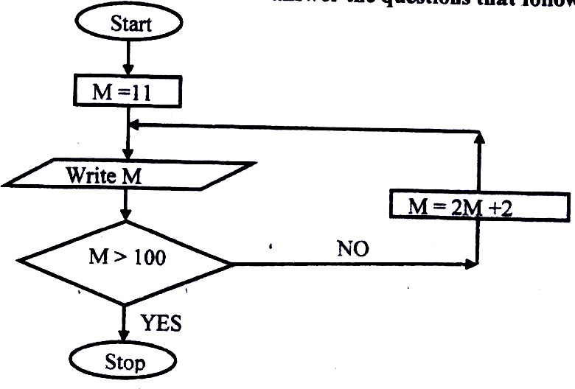
- Study the flowchart below and answer the questions that follow:
List all the outputs from the flowchart. (3mks)
24, 50, 102 (any correct 3)
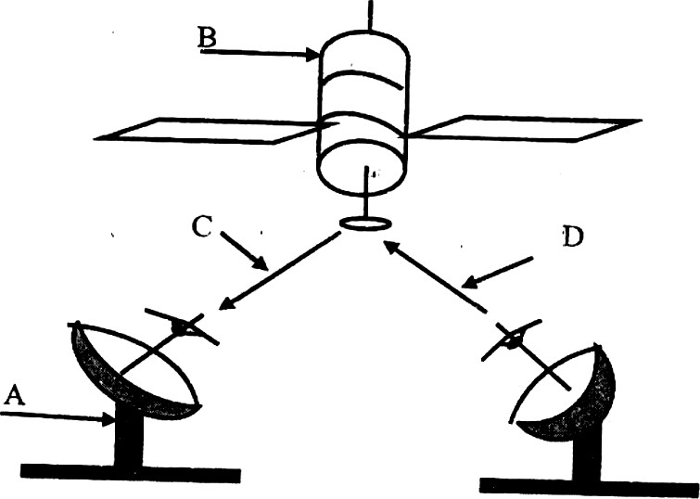
- Study the diagram below and answer the questions that follow:
- Name the communication media depicted in the above diagram. (1mk)
Satellite communication
- Name the parts labelled A, B, C, and D. (4 marks)
A-Receiving earth station
B - Satellite in space
C-Down link
D-Up link
- List three advantages of the above communication media.(3mks)
- It is fast
- It is convenient because; it provides a large constant line of sight to each station Hence, there is no need to keep on moving the parabolic dish so as to track the line of sight
- Can be in very remote areas that do not have high cost physical infrastructure like telephone lines.
- Distinguish between logical and physical network topology. (2mks)
- Logical (signal) topology deals with the way data passes from one device to the next on the network while Physical topology refers to the physical arrangement (layer out) of devices on the network.

Explain the function of the following network devices: (2 marks)
- Network interface card (NIC)
NIC creates a physical link between the computer and the transmission media.
- Repeater
A repeater receives a weak signal on the network, cleans and amplifies it for transmission over the next portion of the network. Signals become weak due to attenuation
- Give three advantages of using fibre optic cables for data transmission. (3 marks)

- Outline four devices required in order to conduct a video conference. (4mks)
- A computer
- A digital video camera (camcorder) attached to a computer
- Network software for video conferencing
- A microphone
- Speakers
- Describe how computing has been applied to each of the following areas:
- Transportation systems. (2mks)
- Used by railway corporations to coordinate the movement of their goods & wagons
- Used in airline industry for air traffic control, surveillance of airspace using radar equipment
- Used in shipping control
- Used in automobile traffic control in busy towns, i.e. to simulate the timing of traffic lights.
- Reservation systems. (2mks)
- To keep record of reservation
- For online reservation (i.e. provide online remote services)
- Paperless transaction (Paying via credit cards)
- Easy to check for vacant positions
- Distinguish between “job replacement” and “job displacement” in reference to Computerization (2mks)
- In job replacement, the unskilled workers may be replaced with the skilled ones. In job displacement, some employees may be displaced/ moved to new working areas as the computer may serve to perform tasks that may be performed by several people.
- Discuss the applications of Artificial Intelligence in Expert Systems. (2 marks)
- In medical institutions for diagnosis of diseases
- In mining companies for prospecting of minerals.
- Financial forecasting, e.g. formulation of taxation & marketing policies, and making of investment decisions.
- Financial forecasting, e.g. formulation of taxation & marketing policies, and making of investment decisions.
- State three reasons why users may resist the introduction of information and communication Technology (ICT) to their place of work
- Fear of change- people are creatures of habit, hence are afraid of change
- Fear of losing their jobs: By installing the computer into an organization, employees fear that they might end up losing their jobs
- Fear of failure – Since the computer is very new in a given working environment, the people will be afraid that they might never get used to it.
- Loss of control: The management fear that once a computer system is implemented, they might lose control of the organization.

  - Name any threes computing resources that can be distributed. (3mks)
- CPU (Processors) time
- Files
- Application software
- Data/information/messages
- Computer processing power
- Memory (computer storage)
- Input/output devices, e.g. printers
- communication devices/communication ports

  - Define the term data integrity. (2mks)
- Data integrity refers to the dependability, timeliness, availability, relevance, accuracy & completeness of data/information
  - State two reasons for using binary in digital technology. (2mks)
- It is easier to develop devices that understand binary language
- Devices designed using binary logic are simple, more reliable & consume less energy.
  - State the importance of hexadecimal notation in a data representation. (2mks)
- Helps to manage long binary digit properly
- Helps to improve the processing speed and optimize memory usage.

Use Two’s compliment to subtract 101 from 1000: (2mks)
Step 1: change the values to 8 binary digits.

000010002 - 000001012

Step 2: Add the binary equivalent of the first value to the Two’s complement of the second value
00001000

11111011 +

(1)00000011 =1000000112 (2mks)
  - Perform the following conversions:
- 7.125₁₀ to binary (2mks)

2 | 7 | Rem
2 | 3 | 1
2 | 1 | 1
 | 1 | 1

=1112

0.12 x2 0.250  0

0.20 x2= 0.500  0

0.500x2=1.000  1

= 0.0012

= 111.0012

7AB₁₆ to decimal (2mks)

16² | 16¹ | 16⁰
7 | A | B

= [7x16²] + [10x 16¹ ] + [11x16⁰]

=1792 + 160 +11 = 196310

- Study the worksheet below and answer the questions that follow:

 | A | B | C | D | E | F
1
2 | SKYWAYS AGENCIES
3 | PRODUCT | REGION 1 | REGION 2 | REGION 3 | REGION 4 | TOTAL  Sale
4 | Rexona | 3400 | 3,700 | 4000 | 4100
5 | Lifebuoy | 2500 | 2600 | 2100 | 2500
6 | Omo | 6000 | 6100 | 6300 | 1600
7 | Ushindi | 1200 | 1500 | 1400 | 6400
8 | Carmel | 7000 | 6900 | 7200 | 8000
9 | Total
10 | Maximum
11 | Average
- Write functions that can be entered to get total, maximum, and average of

each region. |  | (3 mks)
Total | = | Sum (B4:B8)
Maximum: | = | Max (B4:B8)
Average: | = | Average (B4: B8)

- Write down the function that returns the number of sales in the four regions whose value is greater than or equal to 2000.(2 mks)
= SUMIF (B4:E4, “>=2000”)

- The function = sum (B4:E4) is entered at F5 and then copied to F8. Write down the function as it appears in the destination cell. (2mks)
= sum (B7:E7)
- Define the term normalization as used in database design. (2mks) Normalization is the process of trying to eliminate storage of duplicate values in a database.

State two objectives of normalization. (2mks)
  - To relate different tables in a database

  - To ease the retrieval of data from a relational database
  - Breaking up multi theme tables into smaller workable tables

Explain how ‘parents’ and ‘child’ tables are related in relational database. (4mks)

A parent table is the one that has the primary key of the relationship, while a child table is the one that has the foreign key of the relationship.
Parent and child tables are related through a common field that links the two tables. Records in a child table relate to one record in a parent table.

